Assignment 3

|  |  |
| --- | --- |
| Team ID | PNT2022TMID14121 |
| Project Name | Inventory Management System for  Retailers |

Question:

1. Create a Bucket in IBM object storage.
2. Upload 5 images to IBM object storage and make it public. write html code to displaying all the 5 images.
3. Upload a CSS page to the object storage and use the same page in your HTML code.
4. Design a chatbot using IBM Watson assistant for hospital. Ex: User comes with query to know the branches for that hospital in your city. Submit the web URL of that chat bot as an assignment.
5. Create Watson assistant service with 10 steps and use 3 conditions in it. Load that script in HTML page.
6. **Create a Bucket in IBM object storage.**

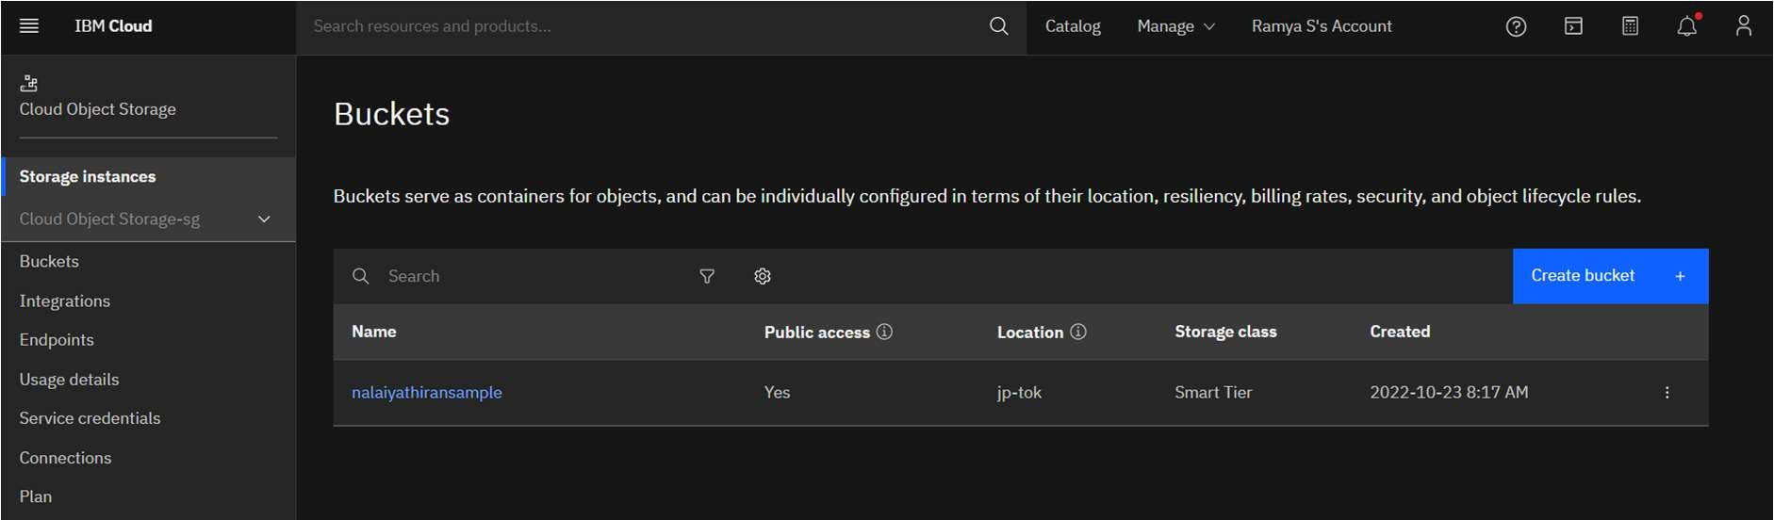

1. **Upload 5 images to IBM object storage and make it public. write html code to displaying all the 5 images.**

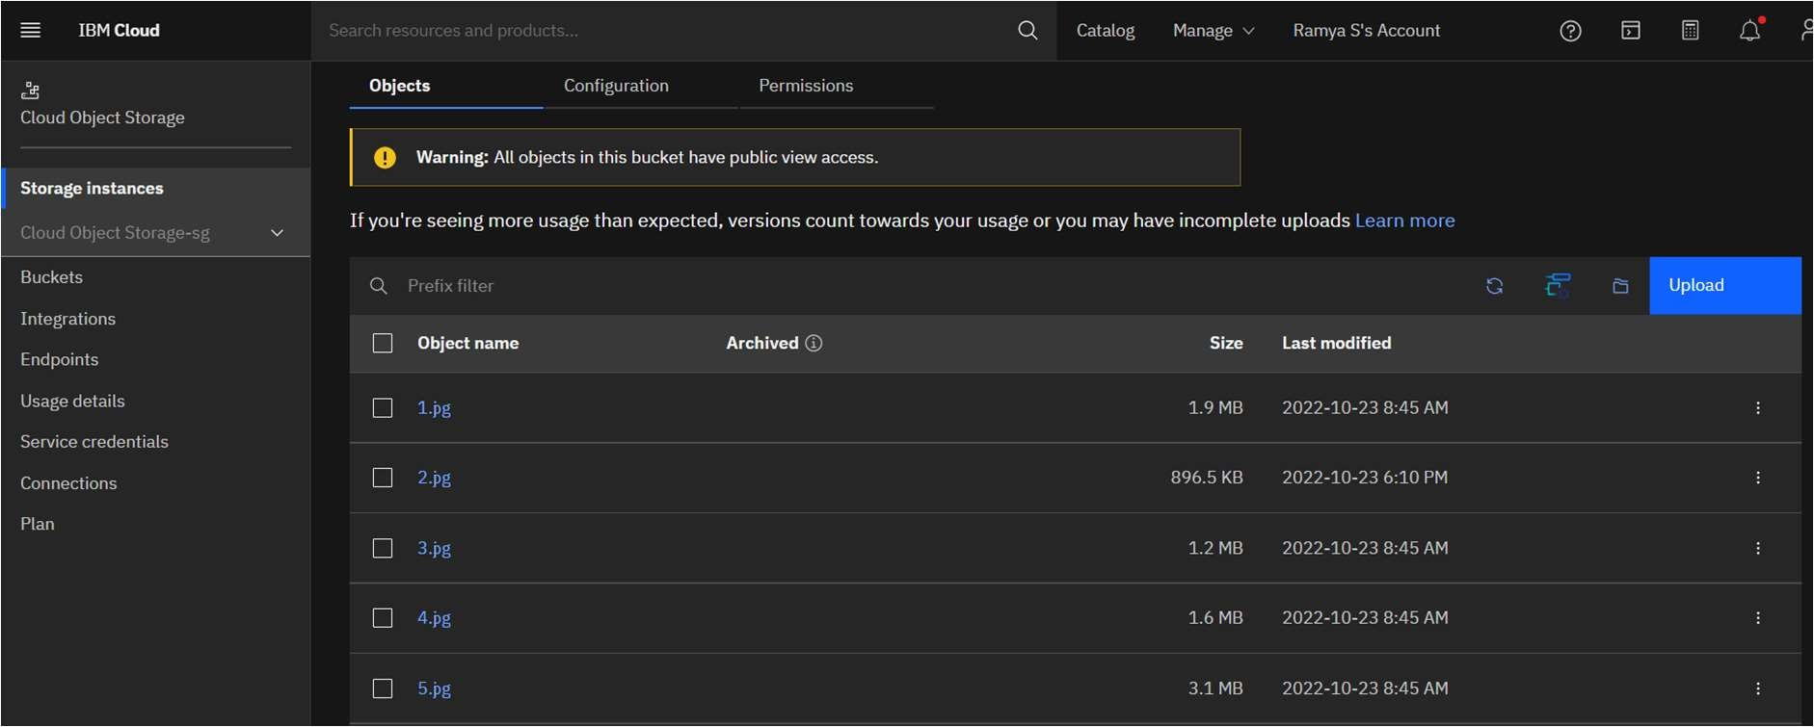

1. **Upload a CSS page to the object storage and use the same page in your HTML code.**

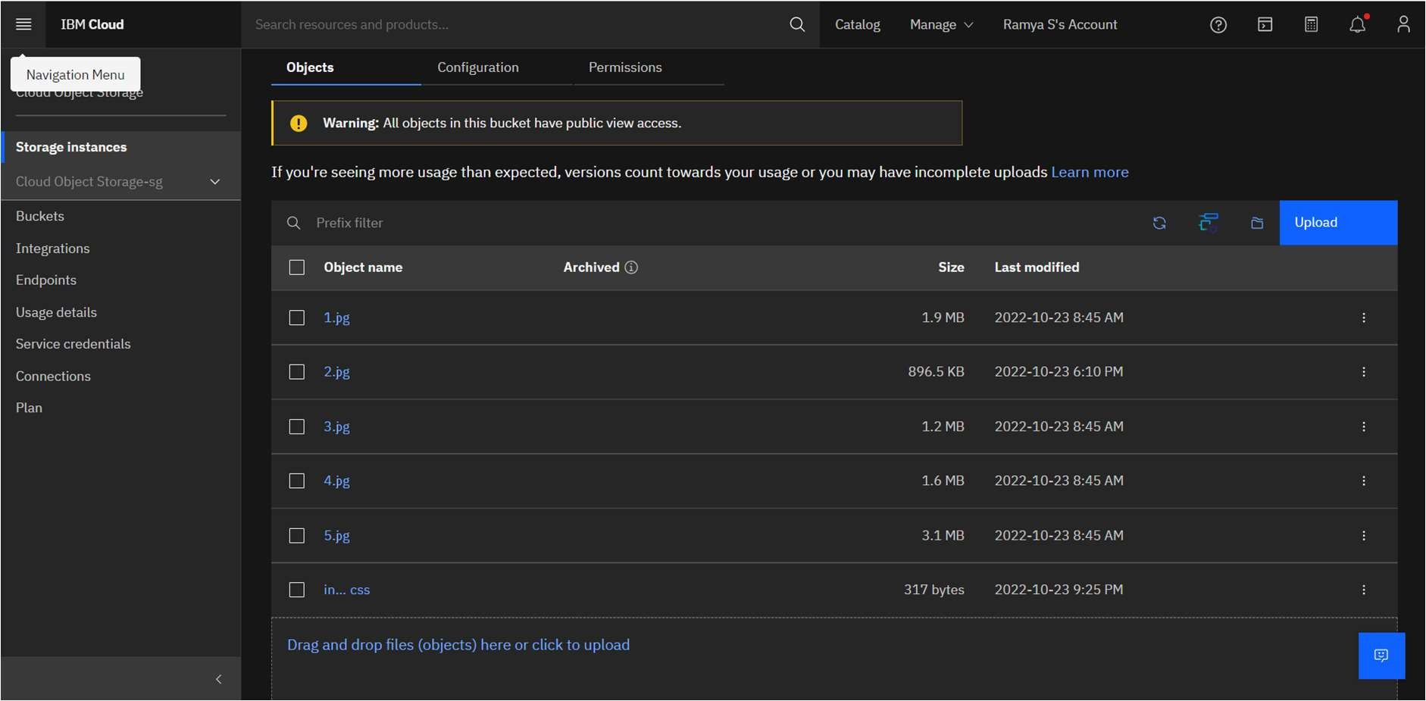

HTML Code:

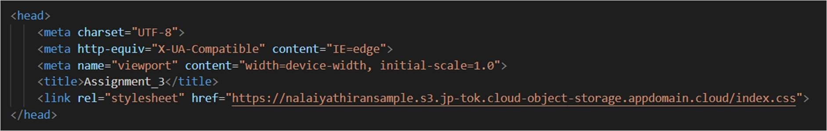

1. **Design a chatbot using IBM Watson assistant for hospital. Ex: User comes with query to know the branches for that hospital in your city. Submit the web URL of that chat bot as an assignment.**

Link :- https://web- chat.global.assistant.watson.appdomain.cloud/preview.html?backgroundImageURL=ht tps%3A%2F%2Fau- syd.assistant.watson.cloud.ibm.com%2Fpublic%2Fimages%2Fupx-2c1e4add-3c78- 4a08-9e41-27049e2e91c3%3A%3A8ed46c39-4d7c-42ca-8ee3-

d31b37be6d30&integrationID=08e35c59-25f0-4a13-8d96-4f511198a1db&region=au- syd&serviceInstanceID=2c1e4add-3c78-4a08-9e41-27049e2e91c3

1. **Create Watson assistant service with 10 steps and use 3 conditions in it. Load that script in HTML page.**

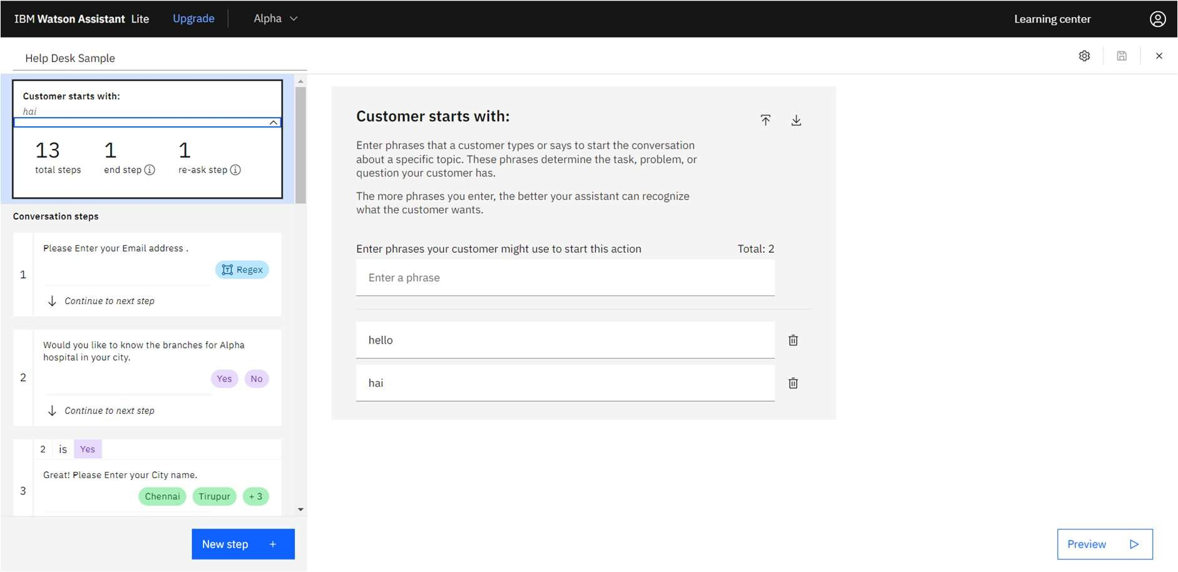

Load the script in HTML page.

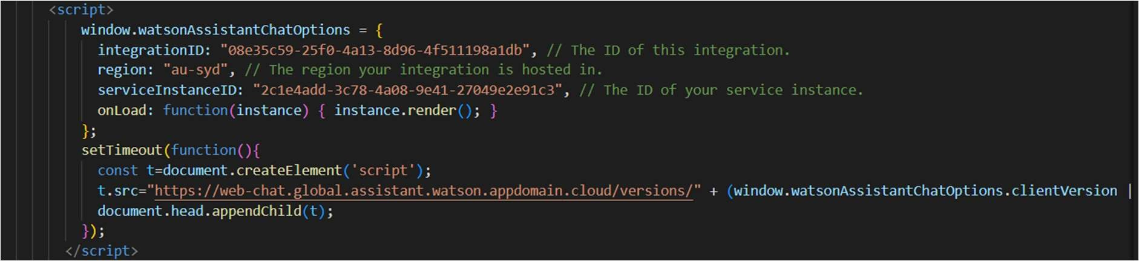

Final Output:

